UNI LIFE 101:

What We Wish We’d Known When We Were Freshers

[Image description: The Cambridge University crest, a red and white cross in the shape of a shield with gold lions in each corner, with a closed book at the centre of the cross]

[Image description: The graphic logo for CUSU (the Cambridge University Students’ Union). The logo is made of the four letters of CUSU in large, bold font, with “CU” in light blue, and “SU” in white inside of a large speech bubble, which is the same blue as “CU”.]

A CUSU Disabled Students’ Campaign Guide to Cambridge

Note

This guide is an adapted version of a presentation given by the CUSU DSO at the September 7th & 12th DRC Transitional Events for students with specific learning disorders who are beginning their studies at Cambridge in October 2017.

The guide is intended to provide information to incoming students to explain the structure of Cambridge University, how it functions on a day to day level, what it’s like to study here, what it’s like to live here, and specific advice on being a disabled student.

While this guide was written with Freshers in mind, it may also apply to current students and prospective students, but likely not to students outside of Cambridge University.

Contacts & Links

Disability Resource Centre Website:
http://www.disability.admin.cam.ac.uk/

Disability Resource Centre Email:
disability@admin.cam.uk

CUSU (Students’ Union) Website:
https://www.cusu.co.uk/

CUSU Freshers Website:
http://www.freshers.cusu.co.uk/

Disabled Students’ Campaign Website:
http://www.disabled.cusu.cam.ac.uk/

Disabled Students’ Campaign on Twitter:
https://twitter.com/CUSU_Disabled

Disabled Students’ Campaign on Facebook: https://www.facebook.com/CUSUdisabledstudents/

Disabled Students’ Officer on Facebook:
https://www.facebook.com/cusudisabled

Disabled Students’ Officer Email:
disabled@cusu.cam.ac.uk

Contents

P.4 – Introduction
P.5 – Is everyone in the same boat?
P.6 – University Structure
P.6 – College
P.8 – University
P.9 – Faculty
P.10 – Supervisions
P.11 – Impostor Syndrome
P.12 – City Life
P.12 – Getting Around
P.14 – Cafés
P.17– Restaurants
P.19 – What to do for free
P.20 – Lectures & Notes
P.21 – Day(s) in the life
P.22 – Essays
P.23 – Mental Health
P.24 – Intermission
P.25 – CUSU
P.28 – GU
P.29 – Jargon buster
P.33 – Links

Introduction
[Image Description: A person (Florence) stands in front of a wire fence, behind which is a river, with a grassy bank and willow trees. She is wearing a yellow & brown shirt, and has blue glasses, light skin, and short blonde hair.]
Hello!
I’m Florence, I work for Cambridge University Students’ Union (usually known as ‘CUSU’) as the Disabled Students’ Officer (or ‘DSO’ for short), so it’s my full time job to represent disabled students in the University and to fight for accessibility and disabled liberation.
It was at University that I was diagnosed as having Dyspraxia, as well as Generalised Anxiety Disorder, and so I’m very keen on spreading information about disability in Cambridge to all students, including those who don’t self-identify as disabled.

I was asked to create this resource by the Disability Resource Centre (the ‘DRC’) to give insider knowledge on what it’s like to be a disabled student at Cambridge, as well as giving some tips and advice about your time here.

My aim when writing this was to cover things that I wasn’t aware of when I first arrived three years ago, so some of these things may be obvious to you already, and some you may have never heard of before, and both are okay, as everyone has different knowledge coming into higher education and different experiences during it.

While I’ve tried to be comprehensive, there’s no reason to try and memorise everything in this guide, and it should still make sense even if you only selectively read certain sections or pages.

I hope you enjoy your time at Cambridge, and feel free to send me an email or message if you ever have any issues, concerns, or ideas regarding disability at Cambridge.

Thanks,
Florence Oulds (CUSU Disabled Students’ Officer)
Is everyone in the same boat?

One thing that everyone has in common when they start University is that they’re probably quite scared and anxious.

There’s lots of reasons for this: You’re in a new place, it probably seems very grown up and serious, you’re probably living away from family for the first time, you’re going to have to make new friends and meet new people, and you’re going to have be looking after yourself.

This worry can be productive. You may do some research on what you’ll need or what your uni is like (you’re doing that right now!), you might do some reading ahead of your course so you already have a strong idea of what it is you’ll be studying over the coming weeks and months.

However, disability may affect your start and run-up to uni, as it may affect how you socialise with people when you are here, or how you cope with the change of moving here, and you may find that your anxiety exceeds that of your peers and carries on past the first few days, or even that you’re dreading starting here.

On my first day here, I remember hearing voices outside my room in the corridor, chatting about all sorts of things and no doubt having the time of their lives. I paced around my room, ineffectively unpacking the masses of books I’d brought with me and feeling like I’d made a huge mistake. Eventually, I summoned up the courage to go out and talk to my new neighbours, and did end up becoming friends with most of them. However, while some of them may have just chucked their stuff in their rooms and been ready to socialise all night, I needed a space that was mine to go to in case I got overwhelmed or anxious.

The point of this anecdote is that it’s totally okay to have to make time and space for yourself and how you cope with change, and doing so doesn’t mean that you’re going to miss out on some quintessential experience of uni life.

It really doesn’t matter if you don’t meet your best friend on the first day, or even if you don’t remember anyone’s names, or have any deep and meaningful conversations, or end up drunk in spoons at 3am.

There’s plenty of time to get to know people and make friends, as well as have exciting experiences and enjoy yourself, so make sure to think about what you can do to relieve any worries you might have about starting uni, but also try not to feel guilty if how you ‘do uni’ is different from everyone else.

University Structure

As you’ve probably heard in every event, email, and prospectus about Cambridge, this place is really really really really old.

It was founded in 1209, and while several things have changed since then, the University still has lots of strange hang-ups that means it doesn’t really run quite like anywhere else, or in a way that makes any actual sense.

Personally, I found the divide of University and College very confusing, and also how my college related to my Faculty, so I’ll do my best to explain some key points. None of this is life-or-death, and it really doesn’t matter if you show up not knowing anything: as long as you sit your exams, you’ll probably survive!

College

Primarily, your College is where you live, which also means it’s probably where you eat, study, and socialise. There are 31 Colleges in Cambridge spread around the city, making it more of a University town rather than a more traditional campus University.

Housing

Your College is in charge of your wellbeing, which includes housing you. Unlike most other universities, Cambridge Colleges usually provide housing for three years (the length of most undergraduate degrees) so you usually don’t have to worry about finding a place to rent. If you have any problems with your accommodation, speak to your College estates or tutorial office.

Food

Wellbeing also includes feeding you, and most College accommodation is semi-catered. This means you will likely have a kitchen with some cooking equipment (toaster, microwave, hob etc.) but likely not a full oven, as your College will provide cooked meals in the buttery or the hall. A ‘buttery’ is more or less a café, and a hall is a catered dining room, usually with a variety of food options (meat, fish, vegetarian etc.) served three times a day.

Your College should let you know in advance what facilities are available to you, and also then what kitchenware you may need if you do wish to cook for yourself. Colleges also have different payment systems for food purchased from them, with some requiring an upfront payment (‘Minimum Meal Contribution’ or MMC) which you then spend on food, and some adding your spending onto your termly accommodation bill. If you struggle with being able to afford food, or have any money problems in general, you should speak to your College’s finance office.

Teaching and Study

While your education and your degree is overseen by the University, as a member of your College it is their responsibility to arrange your teaching. For most subjects, your College will permanently employ academics to teach you and help with your study.

Each year you will be appointed a ‘Director of Studies’ (or ‘DOS’) who personally organises academics who will teach you certain topics or papers. The main personal contact you have with academics at Cambridge will take the form of ‘supervisions’, which you can read more about on page 10. Sometimes these supervisions will be in your college with academics from your college, and sometimes they may be at another college or at your faculty if your college doesn’t have an appropriate supervisor.

This does mean you will likely be taught by different supervisors from other people doing the same subject as you in other Colleges, and you may even study different texts or topics, but the central governance of the University and its Faculties should make sure that all teaching maintains the same high standard, meaning you won’t get a better education at one College than another. If you do have an issue with your teaching however, you should speak to your DoS or your Pastoral Tutor.

Colleges also often have their own multi-subject libraries on site, meaning you having thousands of books and resources very close to hand.

Community

Colleges are their own communities, and as College campuses are often fairly small, these communities can be quite close-knit. While CUSU is the central Students’ Union for all of Cambridge University, every College has its own student union which deals with matters specific to that College. Most Colleges will have a union for undergraduate students (a ‘JCR’) and for mature and postgraduate students (a ‘MCR’), both of which are made up of a body of students elected yearly by students at that College to fulfil specific roles, e.g Men’s Welfare Officer or Access Officer.

Your unions will put on social events, especially for freshers week, but your College will also have its own societies and clubs. CUSU hosts a Freshers Fair every year for you to meet representatives from societies and clubs—this year it will be on October 3rd & 4th on Parkers’ Piece—but your College may also have a small fair for its own groups, so keep an eye out if you want to get involved.

It is really exciting to be able to live with your friends if you do manage to bond with the people in your College, but it really doesn’t have to be the be all and end all of your social life, and there are plenty of social groups in and outside of the University that mean it really doesn’t matter if you happen to not get on with your neighbours.

University

For students, it can seem like the University’s main purposes are to look fancy, have reputations, speak latin, and make people wear bizarre gowns.

As mentioned earlier, the University is in charge of organising education, but it also creates guidelines and rules for how the Colleges within it run.

[Image description: A small flow chart showing the hierarchy of the University and its Colleges, with ‘Uni’ being at the top and a line leading from underneath its box into the top of five boxes below it, which are all parallel and read ‘College’]

Despite this diagram, the University has no real power to tell its Colleges exactly what they should do, and so while it’s easier to think about it as a hierarchy, it’s more of a conversation and agreement.

It isn’t hugely necessary for you as a student to understand this relationship, as most of the time your College will take care of any communication with the University. In some cases, certain procedures may involve correspondence with the Uni, but if this is the case you should have support and guidance from your College.

If you have an issue in your academic life and you’re not sure how to resolve it or who to resolve it with, speak to the Students’ Union’s Advice Service (SUAS), who provide a free, professional advice service for students:

http://www.studentadvice.cam.ac.uk/
advice@studentadvice.cam.ac.uk
01223 746999
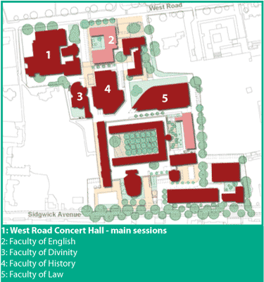

[Image Description: A small site map giving a bird’s eye view of Sidgwick Site. The map looks like an architectural blueprint, showing the borders of the buildings, and the positions of lanes, streets, roads and trees.]

Faculty

Faculties are the bodies that deal with the teaching of specific subjects at Cambridge. For example, there is a History Faculty, an English Faculty, a Law Faculty etc. They are usually contained within a single building, on a single ‘site’ with other adjacent subjects, such as Sidgwick Site (pictured above) and the New Museums Site.

Typically, Faculties arrange lectures for a subject and its separate papers, set the curriculum and reading lists for a subject, and write and mark the end of year exams for each year. The academics at your College that teach a certain subject will also belong to its relevant Faculty, and may be involved in the governance of the subject, making them good people to speak to if you have any questions concerning your Faculty and are uncertain who to talk to.

Faculties will also have libraries for their subject and adjacent or relevant subjects, where you may be able to find more specialist and niche recourses that your College library may not have. Your Faculty may also offer advice and workshops on things like dissertations and essay writing, so look out for these throughout the year, and on your Faculty’s website.

Concerning books, a good piece of general advice is that you shouldn’t buy all the books on your reading list, and should try as much as possible to borrow books, as between your College library, your Faculty library, and the huge University library (http://www.lib.cam.ac.uk/) there should be somewhere that has it. If not, most Colleges and Faculties will have order forms where you can request the purchase of a text you may need. Your University membership also gives you access to online academic databases like JSTOR, which you should make the most of while you can!

Supervisions

Supervisions are Cambridge’s most common kind of contact hours with academics, often taking the form of an hour long chat/debate with a supervisor, either on your own or with a couple other students. In most subjects, supervisions are weekly, and will almost always require preparation, mostly in the form of weekly reading and an essay. Your supervisor will let you know the time and location of your supervisions in advance, as well as the content you should have studied and prepared—you don’t need to just figure it out from the reading list.

In your interviews last December, you likely had an interview that was similar to the supervision style, where an academic prompted you with a question or a problem, and facilitated conversation surrounding the subject. In your interview, the point may have been to show off your knowledge and your ability to think on your feet, but you should really think of your weekly supervisions as the opposite of this, and as relaxed occasions to talk through complex ideas, and to have the attention and insight of someone who’s an expert in their field, not as an opportunity to intimidate your supervision partners.

The prospect of having to talk on a subject for at least an hour a week can be daunting, especially if it doesn’t go well, and you feel like you don’t know anything about the subject that you’re giving up so much of your life (and money) to study.

However, the regularity of supervisions is one of their strongpoints, as no one expects your work or your arguments to be perfect, as if they were there’d be no point being there. Everyone has off days and weeks, and it’s really not shameful to not know what to say, or to have difficulty thinking on the spot.

As supervisions involve academic research, work, and participation as well as social interaction, there are a lot of aspects of supervision which you may find difficult or may present difficulty to you based on specific disabilities.

In general, preparation is the key to success in supervisions, but this doesn’t mean you have to memorise absolutely everything you need to say, and it’s perfectly acceptable to take in notes, or ask your supervisor in advance for questions, or ask them to rephrase or clarify any questions if you’re struggling to understand them.

If you’re unsure how to improve your supervisions however, contact the Disability Resource Centre (http://www.disability.admin.cam.ac.uk/). They may be able to give you specific advice or methods for adapting your study, but may also be able to help if your supervision is not appropriately following any guidelines listed in your Student Support Document (‘SSD’), which gives the reasonable adjustments that supervisors must make to facilitate your disability.

Imposter Syndrome

[Image description: A clipart drawing of a ‘spy’, the outline shows the shape of a cartoonish person in a large overcoat with a fedora. The outline is filled in in black, and within the face are two white semi-circles, which give the impression of menacing eyes.]

It’s very very common in the face of so much new knowledge, and in the presence of people who know so much, to feel like you don’t know anything, and that there’s been a mistake, and that they shouldn’t have let you in, or that you’re just being pitied.

While it’s certainly good to be humble, your getting into Cambridge wasn’t a mistake: there were lots of people who didn’t make it in, and you should try and be proud of your abilities.

That being said, imposter syndrome does more strongly affect disabled students, especially if your learning style differs from that of your peers, or you feel less able to do certain tasks or do them to the standard you would like to under the restrictions the Uni places on you.

Unfortunately, there isn’t really a ‘cure’ for impostor syndrome, as it’s an illogical belief that’s based on a false image of yourself, an image that may have been produced by systematic societal ideas that disabled people are less intelligent or less worthy of opportunity for personal growth, like attending higher education. Having a name for it may help you in isolating ‘imposter syndrome thoughts’, but it may also help to discuss it with friends, peers, and your tutors for solidarity and affirmation of your worth.

Cambridge’s public image as the home of the rich, white, elite can be very alienating if you aren’t part of that group, and this can contribute to feelings that you’re in the wrong place. There are societies and networks for lots of different groups and identities at Cambridge, so getting in touch with them may provide more specific advice if you feel like part of your identity contributes to any alienation, and CUSU also has 5 liberation campaigns that represent different marginalised groups at Cambridge, which you can read more about on page 26.

City Life

The next few pages take a break from academia to discuss what it’s like to live in Cambridge, and give some recommendations for places to go and things to do!

Getting Around

Bikes

Cambridge is quite small, and so most places can be walked to if you’re able to or feel up to it. Because of its size, Cambridge has fostered a bit of a cycling culture, and using a bike is incredibly common here, even for relatively short distances.

There are lots of bike shops to choose from, and some do rentals if you want to try out cycling or have family visiting, but the best deal you’re going to get will be from the bike stalls present at the CUSU Freshers Fair on October 3rd & 4th.

If you’re apprehensive about cycling, or need a quick top up, CUSU is planning on running some cycle safety and training workshops in Michaelmas, so keep an eye out for those!

Buses

As with most cities, buses in Cambridge are fairly regular, and are great for getting to further away places like West Cambridge site where the University Sports Centre is, or if you need to go to Cambridge’s hospital, Addenbrookes.

Buses here can be quite pricey, even for short journeys, so it’s often worth getting a day ticket, which is around £4.

Information on Cambridge’s various bus services can be found here: https://www.cambridgeshire.gov.uk/residents/travel-roads-and-parking/buses/bus-timetables/
Taxis

While not cheap, taxis can be a lifesaver. Cambridge has multiple taxi companies, and it’s always good to have the number of at least one saved in your phone for emergencies. Your College will likely give you the number of a company that they have a good relationship with, but here’s the numbers for a couple of companies just in case:

Panther cabs: 01223 715 715
Camcab: 01223 704 704
A1 Cabs: 01223 313 131

Google Maps

This one may seem obvious, but Cambridge is so small that most places are within walking distance, but also as it is a very old city that often has poor signage, it can be hard to find places that are just a couple of streets away.

As well as showing you the way to places you haven’t been to before, Google maps and other GPS map apps can be useful for showing you quicker ways to get between locations, and as Cambridge has lots of side-streets and alleyways, it’s worth learning some shortcuts for when the centre of town gets busy.

Unfortunately mapping apps don’t usually give information on things like flatness of pavements, width of pavements, dropped curbs etc., and so it’s always worth giving yourself more time than you need when going to a new place if you need to find accessible routes.

Also, if you’re trying to find a building or faculty on a site and can’t find it on a mapping app or on a physical map, most sites have maps online if you google the name and then “site map”.

Cafés

Indigo Coffee House
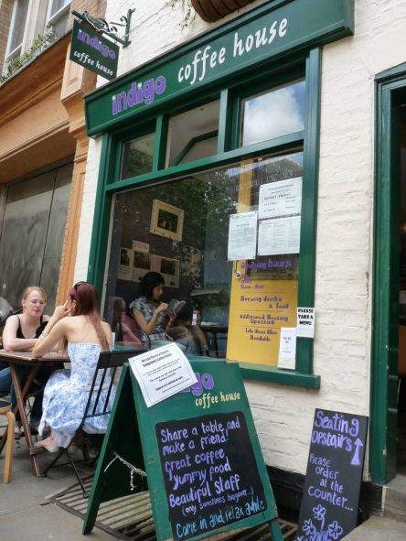

[Image description: A photograph of the exterior of the Indigo coffee house, showing the front window with the name “Indigo coffee house” painted on a green sign above it. There are two people sat chatting at a table outside, a person sat reading a book inside, an A-frame advertising “great coffee” and “yummy food”, as well as a smaller sign advertising seating upstairs”]

The Indigo coffee house is a very cute little café that has amazing tea, coffee, homemade cakes and bagels. The café is quite small, so it can be hard to get a table, but it’s a great place to have a quick getaway from the bustle of town.

Indigo is just off King’s parade in St. Edward’s passage and is right next to Corpus Playrooms, a great venue for student theatre, as well as a couple of great independent bookshops.

Unfortunately there is a step into the café, but there is outdoor seating with movable chairs and tables. Indigo café has a single, gender neutral toilet.

Facebook: https://www.facebook.com/Indigo-Coffee-House-13132328980/
Address: 8 St. Edward’s Passage
Phone: 01223 368 753

Hot Numbers
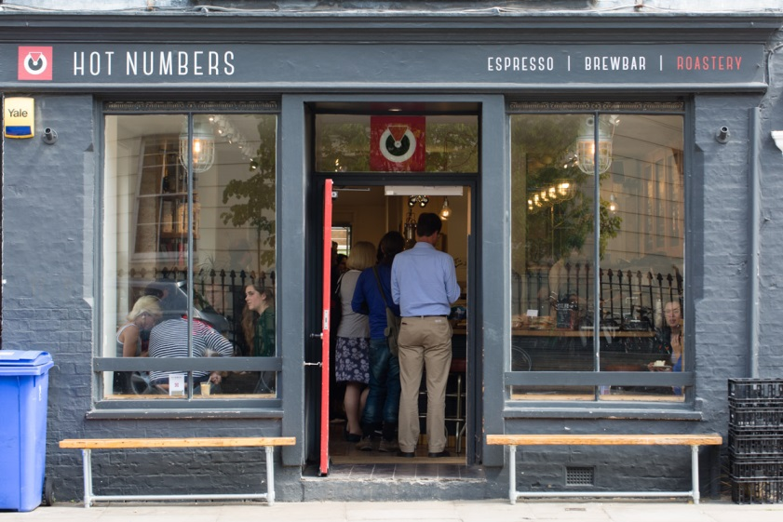

[Image description: A photograph of the exterior of Hot Numbers café, which is painted a light grey. The Café’s sign advertises it as an “Espresso / Brewbar / Roastery”, and inside several people can be seen queuing, while others sit at a table in the window.]

Hot Numbers is a small Cambridge coffee chain, the name being an homage to an old Cambridge record shop. Hot Numbers serves very fancy coffee in a variety of forms, with beans available from all other the world, as well as gourmet food and cake.

There are two Hot Numbers in Cambridge, the more central location being located on Trumpington Street opposite the Fitzwilliam Museum and just down the road from the Disability Resource Centre. The Trumpington Street location also has a step into the café, but the other Hot Numbers on Gwydir Street has step free access, and also hosts live music and events every month. Both Hot Humbers have a single, gender neutral toilet.

Website: http://hotnumberscoffee.co.uk/
Address: 4 Trumpington Street & Dale’s Brewery, Gwydir Street
Phone: 01223 300 730 & 01223 359 966

The Urban Shed
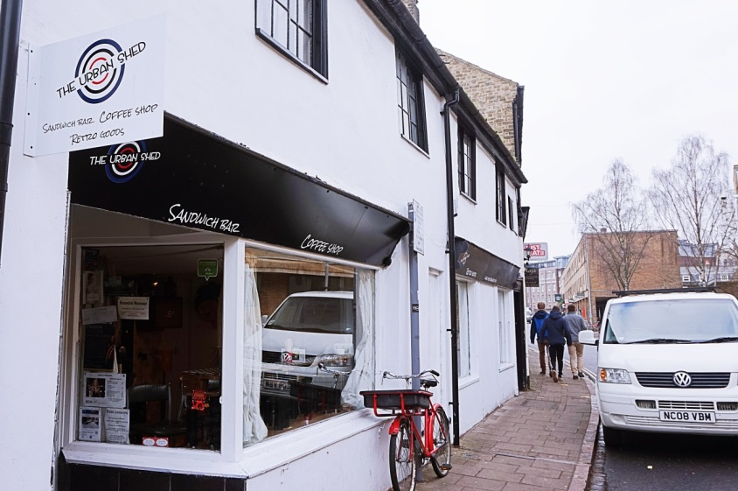

[Image description: A photograph of the exterior of The Urban Shed, showing the café’s location on King Street. The café is painted black and white and has flyers in the window, its sign advertising it as “Sandwich bar, Coffee shop, Retro goods”.]

Urban shed is a small retro café that sells really really really good sandwiches made to order, and any sandwich can be made on gluten free bread to eat in or take away, with a great selection of cakes.

The café does have step free access, but is quite narrow, so wheelchair access is limited to the few tables near the entrance of the café.

Website: http://www.theurbanshed.com/
Address: 62-64 King Street
Phone: 01223 324 888

Restaurants

Rainbow Café

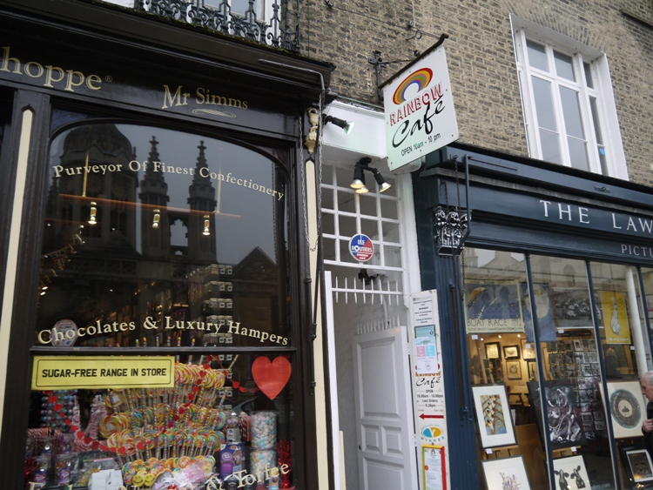

[Image Description: A photograph of the entrance to the Rainbow Café on King’s Parade, a narrow doorway sandwiched between two other shops. The doorway is painted white and the door is ajar, with a sign for the café above the door, and menus and leaflets adorning the side of the door next to an arrow pointing inwards.]

The Rainbow is a small vegetarian, vegan and gluten free restaurant located on King’s Parade. To enter the café you must walk down a short alleyway, open a door, and descend a flight of stairs, meaning it is not suitable for wheelchair users and some mobility aids.

The food can be pricey, but makes a great treat a couple of times a term, with a whole section of the menu dedicated to lasagnes, and great specials and desserts. Unlike most restaurants, the Rainbow doesn’t take reservations, so do your best to get in early! There is a single gender neutral toilet at the top of the stairs.

Website: http://rainbowcafe.co.uk/
Address: 9A King’s Parade
Phone: 01223 321 551

Steak and Honour
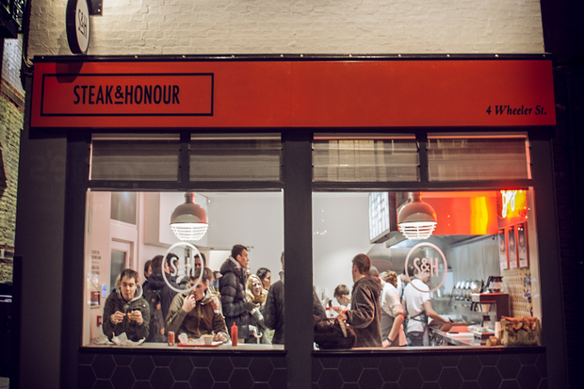

[Image description: A photograph of the exterior of the Steak & Honour restaurant in the evening. The bright interior is visible through the windows, showing a busy store with customers eating and ordering, as well as chefs preparing food, clean “S&H” graphics adorning the windows.]

Steak & Honour is one of many new American-style burger kitchens to have opened up in Cambridge in the last year, and sells superb burgers, with vegetarian options and a variety of toppings and sides.

The restaurant is located right next to the Corn Exchange, which is one of Cambridge’s largest concert venues, and is also used for some end of year exams. There is level access, but most available seating and the toilets are up steep stairs.

Website: http://www.steakandhonour.co.uk/
Address: 4 Wheeler Street

Chains

While these fancy independent places are great, personally I do really like chain restaurants like Nando’s and Zizzis, as they are often very quick and their food is consistent. Never underrate the value of a stress-free meal during term time!

What to do for free

You’ll probably hear about Cambridge clubs and pubs through your College JCR in fresher’s week, but it’s worth mentioning a couple of free (and alcohol free) places to go in Cambridge if you’re needing a break.
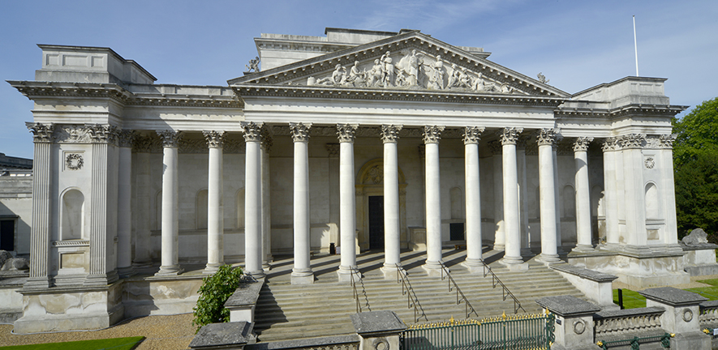

[Image Description: A photograph of the front entrance exterior of the Fitzwilliam Museum taken from an elevated position. Wide rows of steps lead to the flat platform of the entrance, which is covered by a Roman-style roof with columns and friezes.]

The Fitzwilliam Museum is the largest museum in Cambridge. It was founded 200 years ago and is free to everyone, with a level access entrance about 50 meters to the left of the main entrance and lifts throughout the museum. The Fitz has a range of objects and artefacts from across the ages, as well as paintings, sculptures, rotating exhibitions, and a good gift shop.

There are lots of other free museums in Cambridge, like the Zoology museum and the Archaeology and Anthropology museum (a full list can be found here http://www.museums.cam.ac.uk/), and while you’re a student you can get into the University Botanical gardens for free!

Cambridge also has a lot of public green spaces like Christ’s pieces and Jesus Green that are still close to the city centre, but make nice spaces to relax and study. If you can and you feel up to it, it’s really beneficial to spend some time walking around the city and getting used to it, both to discover new places to go, and to get a feel for your new city. You’ll spend about half of the calendar year here, so it’s good to try and treat it like your home, and not just a place to study where looming deadlines stop you from having any fun.

Lectures & Notes

Back to academia! Lectures are a large part of studying at Cambridge (and of most higher education) however their importance does vary between subjects. In some subjects, lectures deliver crucial course content, but in others they may give more peripheral information or context for something you may be studying more independently.

However, you should try and go to as many lectures as possible, making sure to take time for other academic commitments and for rest (i.e. don’t go to a 9am lecture if you were up writing an essay until 2 the night before!) One way of motivating yourself to go to lectures is to think about it as a way of timesaving, as an academic has already done all the reading on a topic and condensed it into a 50 minute talk, so it can be a good commitment even if it disrupts your plans for a more solid stretch of studying.

Unfortunately we don’t currently have standardised lecture capture in all faculties and lecture theatres, but it is being trialled in some subjects, so some of you might be lucky! However, you are the first year at Cambridge where all students are permitted to make personal recording of lectures. You may receive funding for a Dictaphone and editing software, but if you don’t, smartphones have fairly good microphones, and there are plenty of free audio editing softwares like Audacity (http://www.audacityteam.org/). Lecturers do have an option to opt out of being recorded, so please do comply if they ask you to, but if this presents a problem, get in contact with the DRC. Also, lectures recordings are strictly personal, and it’s illegal to share them—so don’t!

Note sharing (both digital and hand-written) is quite common, especially if you aren’t able to attend a lecture, and someone else can get an extra handout and scan their notes for you. It’s a good idea to set up a facebook or whatsapp groupchat with your cohort (the other members of your College in your year who are also studying your subject) to organise note sharing, but also just to generally communicate and query things about your subject and supervisions.

If traditional note taking doesn’t work for you other methods might, such as collaborative note making, where a group of students all take notes together in one shared document (usually a Google doc), requiring less writing per person as well as allowing you to see the connections others make that you may not. You’ll likely have a lot of lectures during your time at Cambridge, so it’s worth trying different methods to find one that suits you best.

Day(s) in the life

What does a day at Cambridge actually look like? Below are two examples of average days, and while everyone works differently, it can be useful to have models to work from. Keep in mind that there’s no right way of doing your day at Cambridge, and that it’s best to try and split your time evenly between work, rest, and leisure.

Day 1
8am | Wake up, shower, breakfast
8:40am | Leave for lectures
9-11am | Attend lectures, go home
11-1pm | Break, lunch
1-3pm | Reading in the library
4pm | Break
5-6pm | Work on weekly essay
6pm | Dinner with friends in hall
7pm | Netflix & rest
11pm | Bed

Day 2
10am | Wake up, breakfast
11-1pm | Sit in bed on laptop
1pm | Lunch in the buttery
1:30-4pm | Sit at desk on laptop
4pm | Look at relevant Wikipedia pages for this week’s essay
4:15pm | More doing nothing on the internet
5:30pm | Go out for dinner with friends
7pm | Go to a pub with friends
12pm | Go home, go to bed

It may seem that like the second day is inherently more “lazy” than the first one, as it has 15 minutes of uni work rather than 5 hours, but it is a reality, and sometimes you might really need a day of barely working or not working at all. You might need this time to think more realistically about any issues you may have, or to do hobbies or projects, or self-care, or societies, or socialise, but also, whatever you’re doing you’re probably thinking about your subject, and for you this might be more productive than sitting down with a pen and paper.

Cambridge is going to involve a lot of work, there’s really no two ways about it, so if you do find a healthy, reasonable, sustainable way of working you should do it, and try not to be ashamed or self-conscious if it’s different from that of others, as they’re just doing what they can to get work done too.

Essays

University essays are quite different from A-level essays, and Cambridge essays themselves are quite strange.

Ultimately, essays are training for your written exams at the end of the year, but you shouldn’t expect them to be perfect, or what you would want your ideal exam essay to look like, especially not in the first term of first year!

The word essay comes from the French word essayer, which means “to try” or “attempt”, and that’s a good way to think about your essays, as a place to experiment with ideas, writing styles, thoughts and feelings, and a place to decide what you do actually think about something.

If you’re stuck with an essay, or just can’t seem to get your words out, it may be worth trying an alternative mode of writing. One method is to write it under timed conditions; you could give yourself two hours to plan and write your essay (which is longer than you will likely have in an exam anyway), and when the two hours is up, stop writing, and submit whatever you’ve written.

Alternatively, you can write an essay as a “plan”, bullet pointing your main ideas/ sources/ discussion, getting down the real meat of the essay without having to worry as much about formal language. A change of scene can also help too, and you may find the silence of a library or the noise of a coffee shop easier to work in and less distracting than working from your room.

In general, it’s better to write an essay that you know there’s problems with than to not write anything, and there’s always the opportunity to talk through issues in supervisions. After you’ve received essay feedback from your supervisor and have taken their comments on board, you never have to think about that essay again. Essays can be useful revision tools for reminding you in brief about a certain topic, or relocating key quotes and information to memorise for exams, but by the time you start your revision you will have improved vastly since you wrote that essay, so sometimes it’s best to resign them to the past and forget about them.

Anyone you meet, no matter how many qualifications they may have or books they’ve written or lectures they’ve given, once knew nothing at all about their topic of expertise. When you begin learning about something, it can expose all of the things you didn’t know, and can leave you feeling quite clueless. This is very normal, and it’s good to adopt a “fake it ‘till you make it” attitude, where you write your essays in a tone that suggests you very confidently believe in what you’re saying, even if you really don’t. Nobody knows everything about anything, and you shouldn’t expect that you will by the end of your course!

Mental Health

[Image description: A graphic representation of the upper part of a human body, with the skin made transparent to reveal an x-ray like image of the skeleton, and the skull also transparent to reveal an orange model of the brain.]

Unsurprisingly, it’s really important to look after your mental health while at university.

Moving here involves lots of big transitions: establishing a new work schedule, being in a new environment, making new friends, changes in how you may normally socialise, and possibly even disruptions to your diet and what you normally eat. Because of this, your support systems can also be disrupted, and it might be hard if you normally reply on certain methods of self-care or beneficial relationships with family or friends.

This sounds quite scary, but is worth being aware of, as it’s very easy to get in the habit of prioritising your work over your health, and because Cambridge terms are so short (8 weeks), it can be hard to catch up if you need a longer break to recover.
In very practical terms, it’s always better to get a good night’s sleep than stay up finishing a piece of work. Your degree is for your and only your benefit, so you should prioritise yourself, but obviously mental health doesn’t work in a logical or fair way, so it’s worth keeping that in mind if you catch yourself forming negative or harmful habits and behaviours.

One last thing: don’t be afraid to ask for help. A common problem is thinking that your problems are too small, don’t matter, or can’t be helped, but there are several services you can access that are there for you, and so you’re not taking up anyone else’s time or space. Both the University Counselling Service (https://www.counselling.cam.ac.uk/) and the Disability Resource Center (http://www.disability.admin.cam.ac.uk/) can give advice and aid on coping with and resolving mental health issues.

Intermission

[Image description: A graphic of drawn red stage curtains, similar to ones that you would find at an old theatre or cinema]

For several different reasons, sometimes continuing with your current year of study is not always the right option.

Cambridge has a procedure generally known as “intermission” (the official name is “disregarding terms”) where you leave your studies at the University, and usually your accommodation, and come back at a more appropriate time, usually in a year’s time or at the beginning of the next academic year.

If University is having a serious impact on your health, or an unfortunate circumstance arises in your life (such as bereavement), sometimes returning to uni at a later stage can be the best option, especially if you need to time to rest or recover from an illness of trauma. There’s no shame in intermitting, and it’s not intended to give you an advantage over other students by giving you an “extra” year of study, but by removing mitigating circumstances that may put you at a disadvantage.

If you are considering intermitting, speak to your Director of Studies, your Pastoral Tutor, your College’s Senior Tutor, or the Student Unions’ Advice Service (http://www.studentadvice.cam.ac.uk/). For more detailed information, there is a full guide created by the Disabled Students’ Campaign which explains the ins and outs of intermission available at http://www.disabled.cusu.cam.ac.uk/intermission/.

CUSU

[Image description: A photograph of CUSU’s 6 sabbatical officers sat on a high wall in front of the Cam river, with their legs dangling. The officers are smiling, chatting, and laughing. In the background there are punting boats and old brick buildings. From left to right the officers are Micha (Welfare), Florence (Disabled students), Olivia (Access), Martha (Education), Daisy (President), Lola (Women’s)]

As mentioned at the beginning, CUSU is the Cambridge University Students’ Union, which means that whatever kind of Cambridge student you are, we’re here to represent you, and make your experience as a Cambridge student the best it can possibly be.

CUSU acts on behalf of students to make change in the University and in the city, looks after student welfare, and acts as the unified voice of students at Cambridge.

We’re a charity, and have a full time team of staff who help run the union, as well as six “sabbatical officers” (or “sabbs”), who are either recently graduated students, or students who have paused their studies to perform their roles. Each sabb has a particular area of expertise or activism:
- Daisy Eyre, President (president@cusu.cam.ac.uk)
- Micha Frazer-Carroll, Welfare and Rights Officer (welfare@cusu.cam.ac.uk)
- Martha Krish, Education officer (education@cusu.cam.ac.uk)
- Olivia Hylton-Pennant, Access and Funding officer (access@cusu.cam.ac.uk)
- Lola Olufemi, Women’s Officer (womens@cusu.cam.ac.uk)
- Florence Oulds, Disabled Students’ Officer (disabled@cusu.cam.ac.uk)
We all work full time, Monday to Friday, 9-5 (mostly), and it’s literally our job to help you out and represent you in any way we can. Currently our SU at 17 Mill Lane isn’t the social hub we’d like it to be, but that’s mainly because each college has JCRs and/or MCRs that largely cater to the College’s individual needs. We are working on sprucing it up however, so watch this space!
Liberation Campaigns
Within CUSU there are five “Liberation Campaigns” that work autonomously from CUSU for the liberation of various groups and categories of students.
CUSU acknowledges that certain characteristics and identities complicate the lives of students both in and out of their studies, and the liberation campaigns exist to fight for the rights of these students groups to ensure equal opportunity and to unwork structural inequalities within the University and wider society. Each campaign has its own student committee, which steer its actions and campaigns, but all students who belong to the defining characteristic of each group are instantly part of that campaign, and form part of its voting body.

Black and Minority Ethnic Students Campaign (BME)
The BME campaign exists to voice the concerns, address the issues, cater to the needs of, and improve the educational and social environment for Ethnic Minority Students at Cambridge.
http://www.bme.cusu.cam.ac.uk/ https://www.facebook.com/CambridgeBME/
Disabled Students Campaign (DSC)
The DSC represents all self-identifying disabled students at Cambridge, including those without diagnosis and with mental health issues, and works not for tolerance but for adaptation .
http://www.disabled.cusu.cam.ac.uk/ https://www.facebook.com/CUSUdisabledstudents/
International Students Campaign (iCUSU)
iCUSU represents the large section of the student population who come from overseas to study at Cambridge, focusing on well-being and access for under-privileged groups abroad.
http://www.international.cusu.cam.ac.uk/ https://www.facebook.com/iCUSU
CUSU LGBT+
CUSU LGBT+ is for students who identify as asexual, bi, gay, intersex, lesbian, queer, trans, or any related identities, or who are questioning their gender identity or sexual orientation.
http://www.lgbt.cusu.cam.ac.uk/ https://www.facebook.com/groups/2202197406/
Women’s Campaign (WomCam)
The Women’s Campaign represents all women and non-binary students in the University, campaigning on issues that affect them and working to improve their university experience.
http://www.womens.cusu.cam.ac.uk/ https://www.facebook.com/CUSUWomen/

GU
[Image description: The Graphic logo for the GU (Cambridge University Graduate Union), the core image being a purple shield shape with a white graphic of an open book above two crossed ladles. Below the image is curved text which reads “Serving since 1955”, and below that is text which reads “Graduate Union at the University of Cambridge”]
Cambridge is one of a handful of Universities in the UK that has a Graduate Union, which focuses specifically on graduate and mature students. Graduate students are those who are studying for any degree higher than an undergraduate degree (typically a Masters or a PhD), and Mature students are students in any degree who begin their course at or after the age of 21, or whose course has them in residence for longer than 3 years.

While CUSU does also represent grads, the GU exists specifically to address four key areas of interest for grads: representation, services, welfare, and events.

The GU has three sabbatical officers:
- Darshana Joshi, President (president@gradunion.cam.ac.uk)
- Ellie Chan, Vice-President (vice-president@gradunion.cam.ac.uk)
- Micha Frazer-Carroll, Welfare and Rights (welfare@cusu.cam.ac.uk, shared with CUSU)
The ‘services’ offered by the GU include thesis binding, gown purchase and rental, and printing, as well as selling cycle safety kits and NUS extra cards, which can all be purchased from reception in the GU lounge, located at 17 Mill Lane above CUSU and adjacent to the GU office and the SUAS office.
For more information about the GU, visit their website https://www.gradunion.cam.ac.uk/, and check out their yearly handbook for Graduate students https://www.gradunion.cam.ac.uk/prospective-students/GU-handbook.

Jargon Buster
(Some definitions taken or adapted from the Queens’ College Jargon Buster http://www.queens.cam.ac.uk/life-at-queens/about-the-college/university/the-jargon)
ADC – Amateur Dramatics club (theatre)
Accomodation – Rooms, where you live
Aegrotat – A declaration by the university that a student deserved to have passed a failed examination, usually on account of illness.
Alumnus – Former student of the University
ARU – Anglia Ruskin University, a neighbouring University in Cambridge
ASNaC – Anglo-Saxon, Norse and Celtic (course)
Backs – Area of Cambridge, behind King’s, Queens’, Clare Colleges etc.
Bedder – Housekeeper, cleaner
Blue – Sporting award given by certain clubs after a match against Oxford
Bumps – Type of rowing race
Bursar – College admin officer, usually involved in finance
Buttery – Café-esque college food & drink seller
BME – Black and Minority Ethnicity students, CUSU has a BME campaign (see p. 26)
Caius – Gonville and Caius college, pronounced ‘keys’
Cam / Camb – General abbreviation for Cambridge, often used as a prefix (E.g. Camdram, the Cambridge equivalent of IMDB)
Cambridge Bubble – The feeling that Cambridge is it’s own little world, and of being so consumed by it that you forget that the rest of the world isn’t like this, and that Cambridge isn’t your whole life
The Cambridge Student – (TCS) Student news site, funded by CUSU
Catz – St. Catherine’s College
Class – Method of grading, a ‘first’ being a higher grade, a ‘second’ being divided into a ‘2.i’ (two-one) or ‘2.ii’ (two-two), and a ‘third’
Class List – Physical posting of finalists results outside Senate House
Cohort – The other students in your College in your year studying the same subject as you, a group that you may have called your “class” in prior education
College – Organisations within Cambridge to which students belong (see p. 6)
Combination Room – Common room, used also for JCR (junior combination room) and MCR (middle combination room) to refer to representative student bodies even if there is no actual common room
Compsci – Computer sciences student
Cuppers – Intercollegiate sporting knock-out competitions
CUSU – Cambridge University Students’ Union (see p. 25)
CUSU LGBT+ - CUSU’s Lesbian, Gay, Bisexual and Transgender campaign (see p.26)
Dean – Senior College officer
Department – Part of University devoted to a particular academic subject
Director of Studies – (“DoS”) College officer who oversees an undergraduate’s studies, usually appoints supervisors
Don – Colloquial term for a Fellow of a College
Double First – High grade achieved by a first in both parts of a Tripos
DRC – Disability Resource Centre
DSC – Disabled Students’ Campaign (see p. 26)
DSO – Disabled Students’ Officer (see p. 4)
Easter – Third term of the academic year
Emma – Emmanuel College
Estates – Department of University (and Colleges) that maintains owned buildings
Faculty – Collection of departments that handle the teaching of a specific subject (see p. 9)
Fellow – Academic post in a College
Finalist – Student in their final year of study
Finals – End of year exams of the last year of a students study
Fitz – Fitzwilliam College
Fitzbillies – A Cambirgde café, famous for its Chelsea buns
The Fitzwilliam Museum– Cambridge’s biggest museum
Footlights – University comedic drama society
Formals – Formal three course meal hosted by a College
Fresher – First year student
Freshers Week – The first week of October, when students have moved into Cambridge but term has not yet officially started, and when Cambridge institutions host orientation events
Gown – Item of academic dress, differing in design by College and degree, required by some colleges to attend formals
The Grafton Centre – Shopping centre in Cambridge
GU – Graduate Union (see p. 27)
Gyp-room – Small kitchen with some cooking equipment, but usually not an oven
Half Blue – Blue in some minor sports
Hall – College dining hall, but also usually used as a phrase to refer to a catered meal eaten in the Hall (e.g. “Let’s go hall”)
Halls of Residence – Student housing, usually within a College’s grounds
Hostel – College residential building outside of College grounds
iCUSU – CUSU International Students’ Campaign (see p.26)
Imposter Syndrome – The feeling that you don’t belong here, that some mistake has been made in your admission (it hasn’t) (see p. 11)
Intermission – Leaving current studies to return at a later date (see p. 24)
JCR – Student group that represents the interests of the undergraduate students of a certain College
June Event – Smaller and cheaper version of a May Ball, Colleges often alternating between June Events and May Balls between years
King’s Parade – Street in central Cambridge on which King’s College is located, a hotspot for tourists
Lent – Second term of the academic year
Lion’s Yard – Central Cambridge shopping centre
Long Vacation – Summer Holiday between the Easter term of one academic year and the Michaelmas term of the next
Lucy Cav – Lucy Cavendish College
Master – Name for the head of the College at most Colleges
Mathmo – Mathematician
Matriculation – To become a member of the University, often symbolised by a Matriculation ceremony
May Ball – End of year parties hosted by Colleges
May Week – Two weeks in June, celebratory period after exams
MCR – Student group that represents the interests of graduates and mature students of a certain College
Michaelmas – First Term of the academic year
Mill Lane – University site where various faculties can be found
MML – Modern and Medieval Languages
Natsci – (Pronounced ‘nat-ski’) A person who studies natural sciences
New Museums – University site
Parkers Piece – Large section of green space near the centre of town
Part – Section of an undergraduate degree (usually Part I and Part II)
PGCE – Postgraduate Certificate in Education
Pigeonhole – (“Pidge”) Small mailbox, usually in Colleges near the Porter’s Lodge
Porter – Member of non-academic college staff who are public and student facing, very knowledgeable about College buildings, services & staff
Porter’s Lodge – (“Plodge”) Reception or room where Porters work and can be found
Preliminary Examination – (“Prelims”) University examination, usually in the first year, which has no bearing on final qualification
Proctor – University disciplinary officer
Punt – Long boat used for “punting” along the river, propelled by sticking a large pole into the river and pushing off from the river bed, can be hired from multiple companies along the river
Read – To study (e.g. “she’s reading Law”)
Regent House – Legislative body of the University
RFB – Raised Faculty Building, home of many faculties on Sidgwick site
Scholarship – College award of a small income to a student
Senate House – Building where graduation ceremonies are held & Class lists are posted
Sidgwick – (“Sidge”) University site
Smoker – Comedy revue show
Societies – (“Soc”) Student run groups pertaining to particular interests (e.g. Chess)
Squash – Party with the object of introducing large numbers of people to a club or society
Stash – Clothing or merchandise from a particular College, society, or group
Statu Pupillari – The state of being an undergraduate or graduate student in the university
Supervision – Typically an hour long meeting with an academic tutor (a supervisor) to discuss a topic (see p. 10)
The Tab – Student news site, part of a wider student news organisation
Term – Division of the academic year, eight week long periods of study with five week breaks in between them (In order: Michaelmas, Lent, Easter)
Tit Hall – Trinity Hall College
Town & Gown – Terms used to distinguish between non-University parts of Cambridge (Town) and Cambridge itself (Gown)
Tripos – Name for the undergraduate courses at Cambridge (e.g. English Tripos)
Tutor – College officer who does not teach you, a tutor assigned to you to help
UCS – University Counselling Service
UL – University Library
Undergraduate – A student doing an undergraduate degree; a student who does not yet have a degree
Union Society – Cambridge debating society, NOT a students’ union
Varsity – Student Newspaper
Vice-Chancellor – The effective head of the University
Week – Numbered weeks which make up a Cambridge term, always running from Thursday to the following Wednesday (e.g. “This essay is due in Week 3”)
West Cambridge – University site
WomCam – CUSU Women’s Campaign (see p.26)

Links

CUSU
Website: https://www.cusu.co.uk/
Freshers website: http://www.freshers.cusu.co.uk/
General Enquiries: enquiries@cusu.cam.ac.uk
Phone: 01223 333 313
17 Mill Lane, Cambridge, CB2 1RX

CUSU SABBATICAL OFFICERS
Daisy Eyre, President (president@cusu.cam.ac.uk)

Micha Frazer-Carroll,
Welfare and Rights Officer
(welfare@cusu.cam.ac.uk)

Martha Krish, Education officer (education@cusu.cam.ac.uk)

Olivia Hylton-Pennant,
Access and Funding officer (access@cusu.cam.ac.uk)

Lola Olufemi, Women’s Officer (womens@cusu.cam.ac.uk)

Florence Oulds,
Disabled Students’ Officer (disabled@cusu.cam.ac.uk)

GU
Website: https://www.gradunion.cam.ac.uk/
17 Mill Lane, Cambridge, CB2 1RX

GU SABBATICAL OFFICERS
Darshana Joshi, President
(president@gradunion.cam.ac.uk)

Ellie Chan, Vice-President
(vice-president@gradunion.cam.ac.uk)

Micha Frazer-Carroll,
Welfare and Rights Officer
(welfare@cusu.cam.ac.uk)

DISABLED STUDENTS’ CAMPAIGN
Website: http://www.disabled.cusu.cam.ac.uk/
Facebook: https://www.facebook.com/CUSUdisabledstudents/
Twitter: https://twitter.com/CUSU_Disabled

CUSU/GU STUDENT UNION’S ADVICE SERVICE
Website: http://www.studentadvice.cam.ac.uk/
Email: advice@studentadvice.cam.ac.uk
Phone: 01223 746 999
17 Mill Lane, Cambridge, CB2 1RX

UNIVERSITY COUNSELLING SERVICE
Website: https://www.counselling.cam.ac.uk/
Email: counsellingreception@admin.cam.ac.uk
Phone: 01223 332 865
2-3 Bene’t Place, Lensfield Road, Cambridge, CB2 IEL

DISABILITY RESOURCE CENTRE
Website: http://www.disability.admin.cam.ac.uk/
Email:
disability@admin.cam.ac.uk
Phone: 01223 332 301

